**LOGIN PAGE**

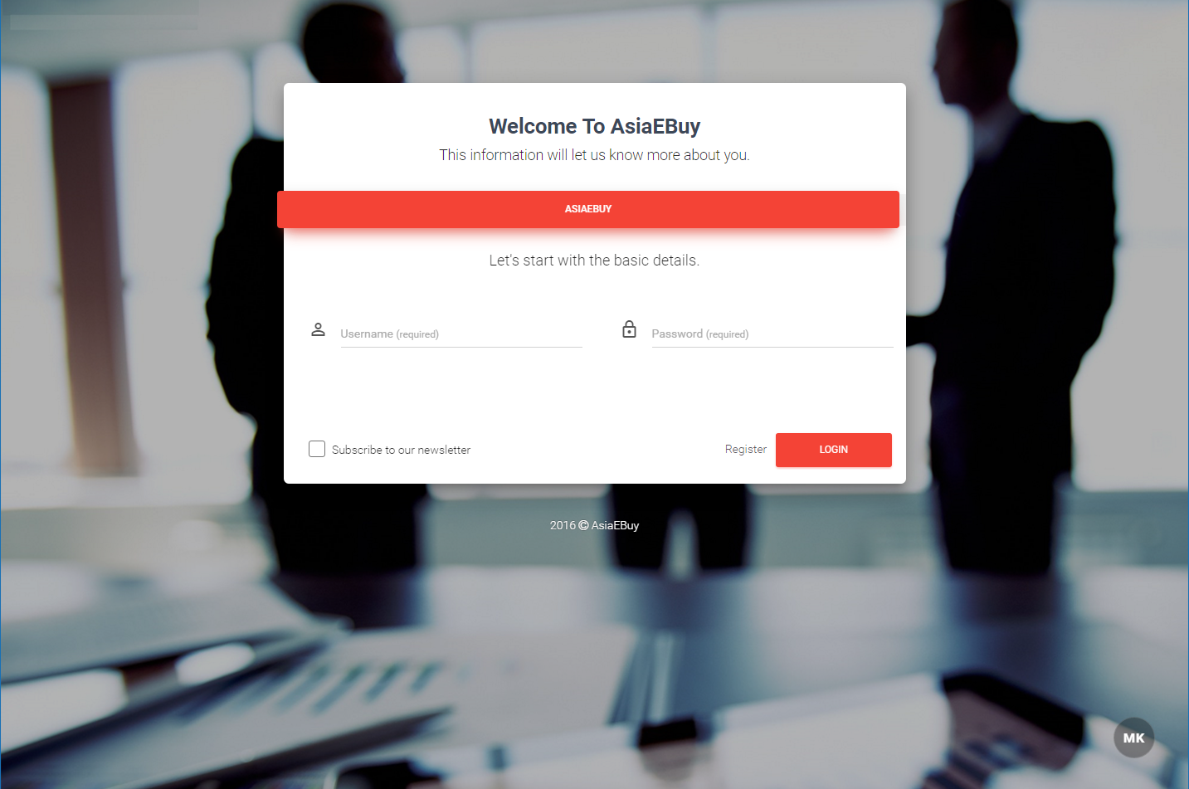

**CHOOSE FOR REGISTERATION ( BUYER / SELLER )**

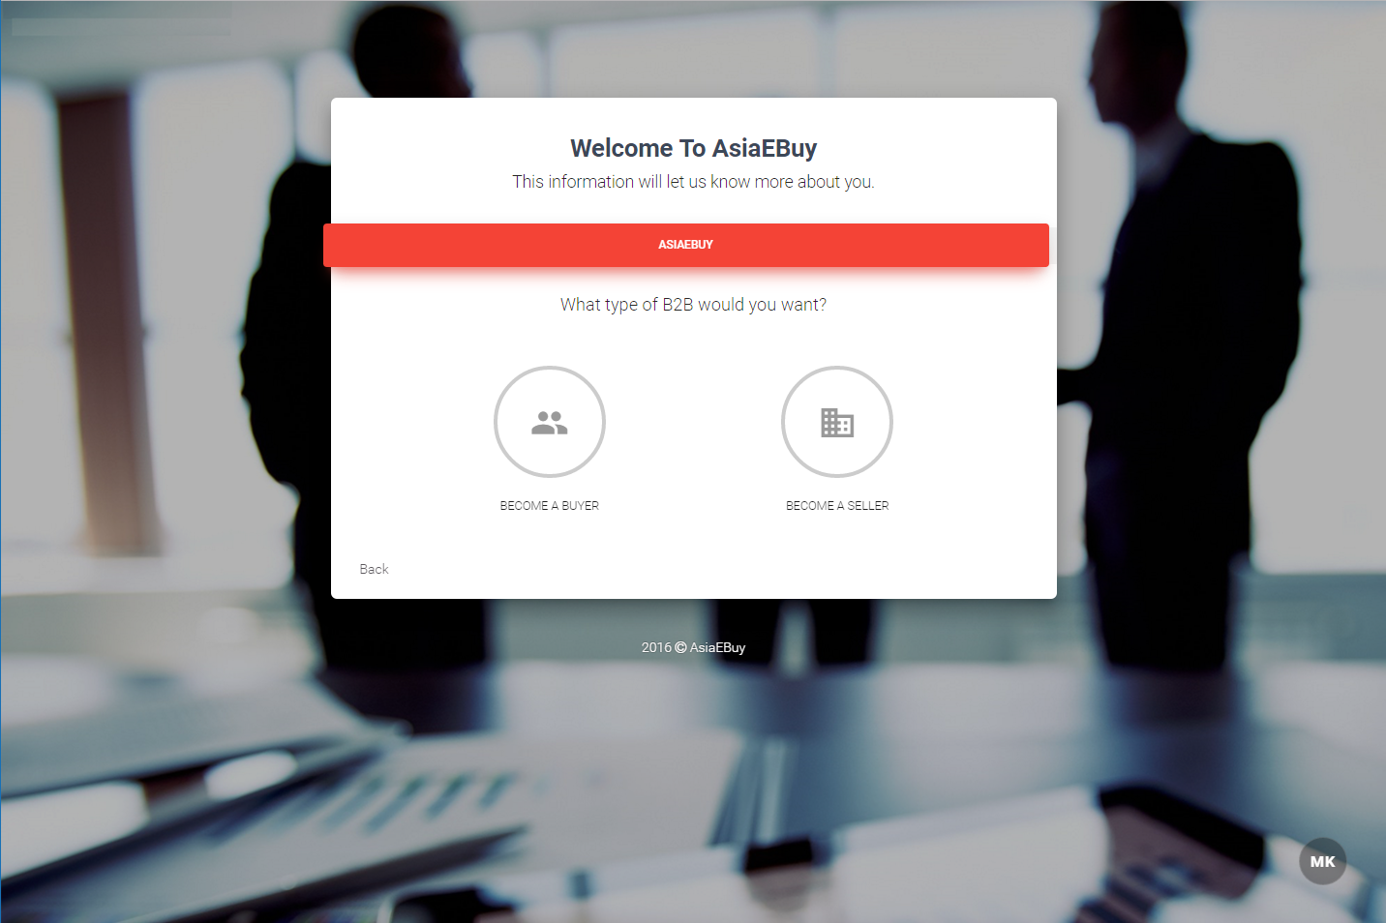

**BUYER REGISTERATION PAGE 1**

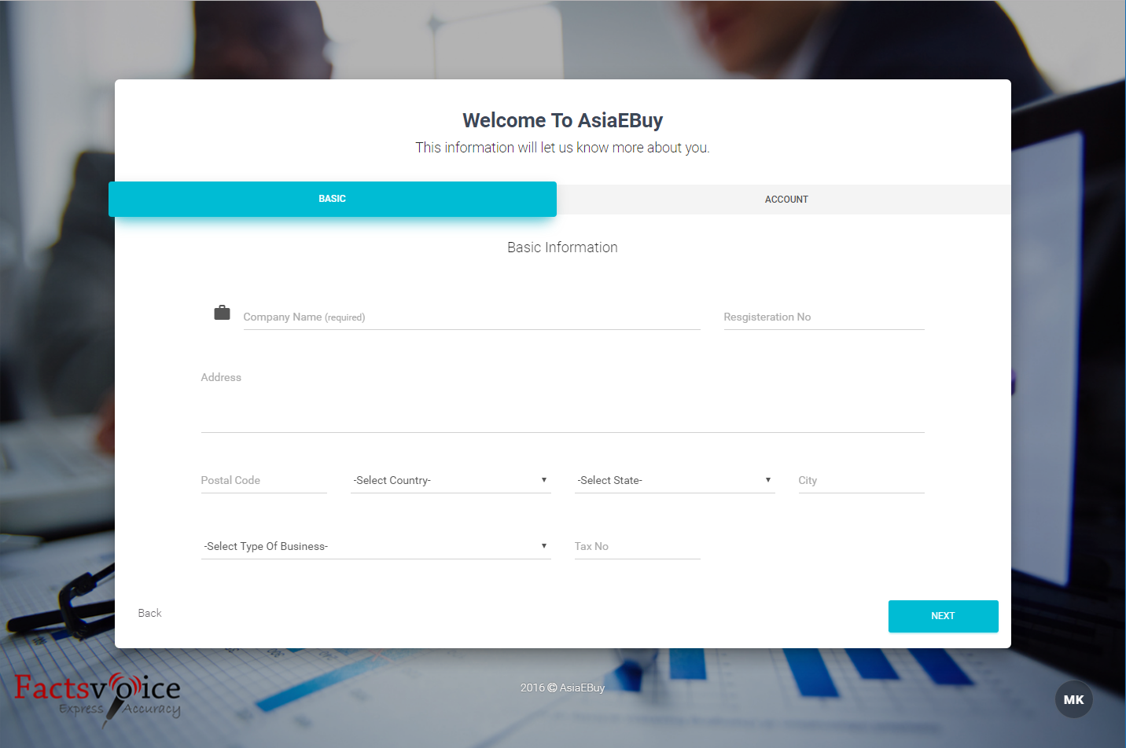

**BUYER REGISTERATION PAGE 2**

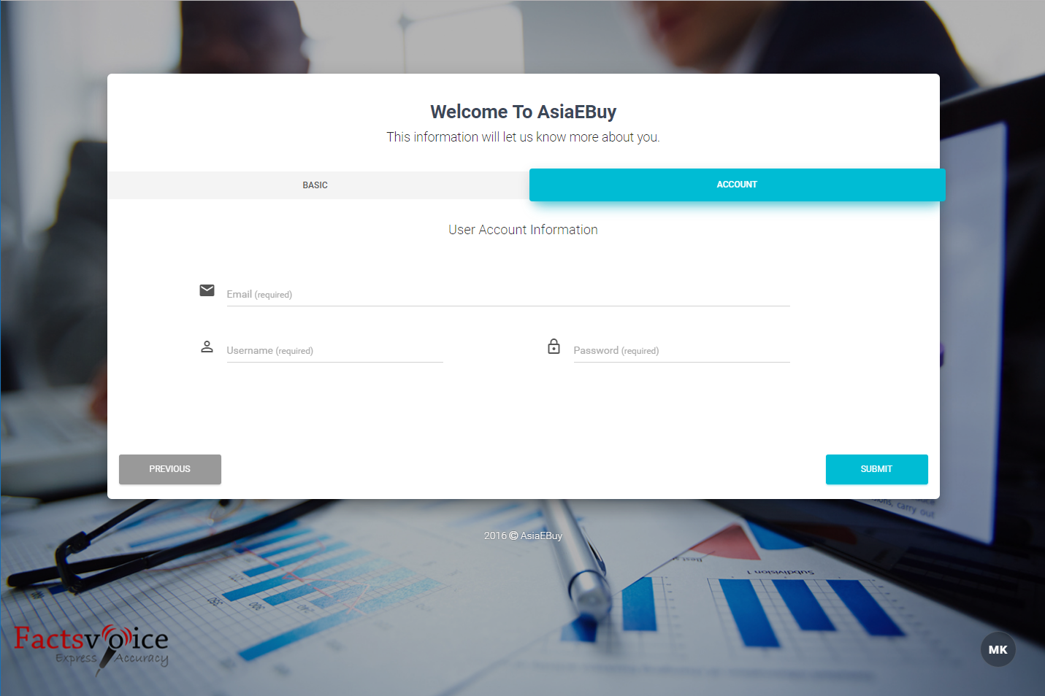

**SELLER REGISTERATION PAGE 1**

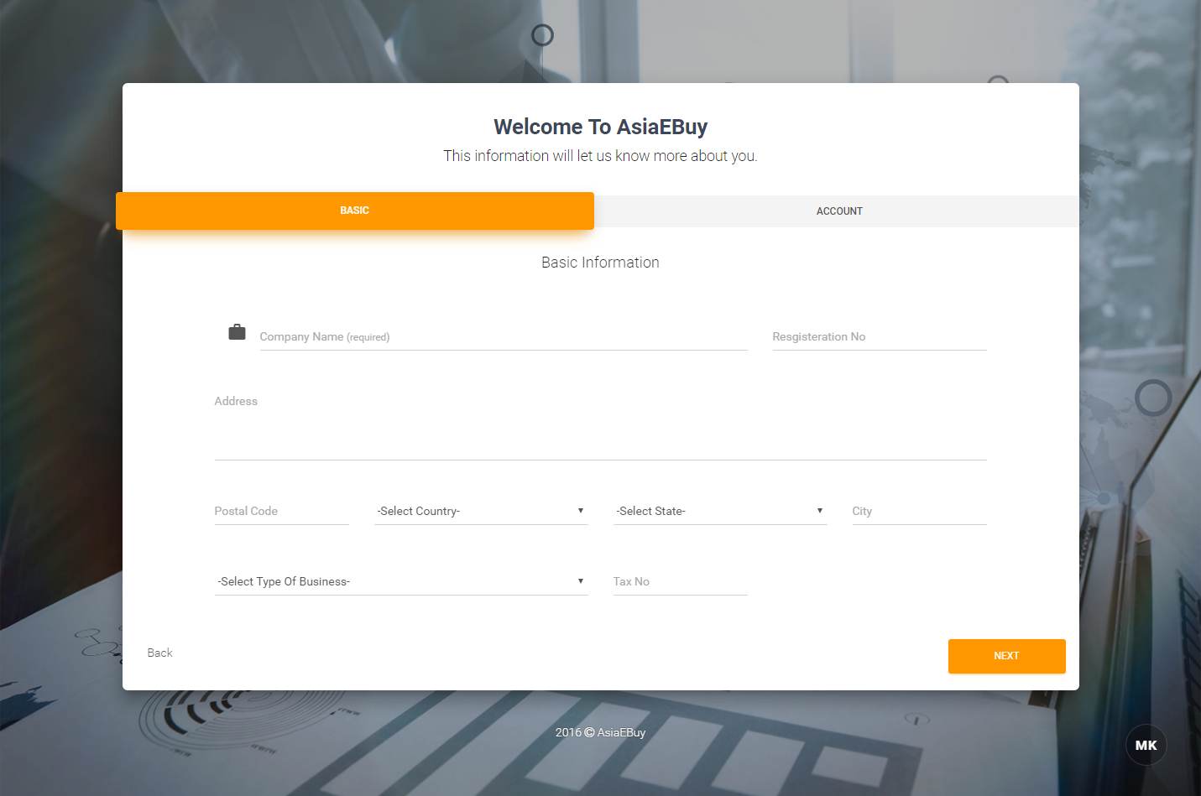

**SELLER REGISTERATION PAGE 2**

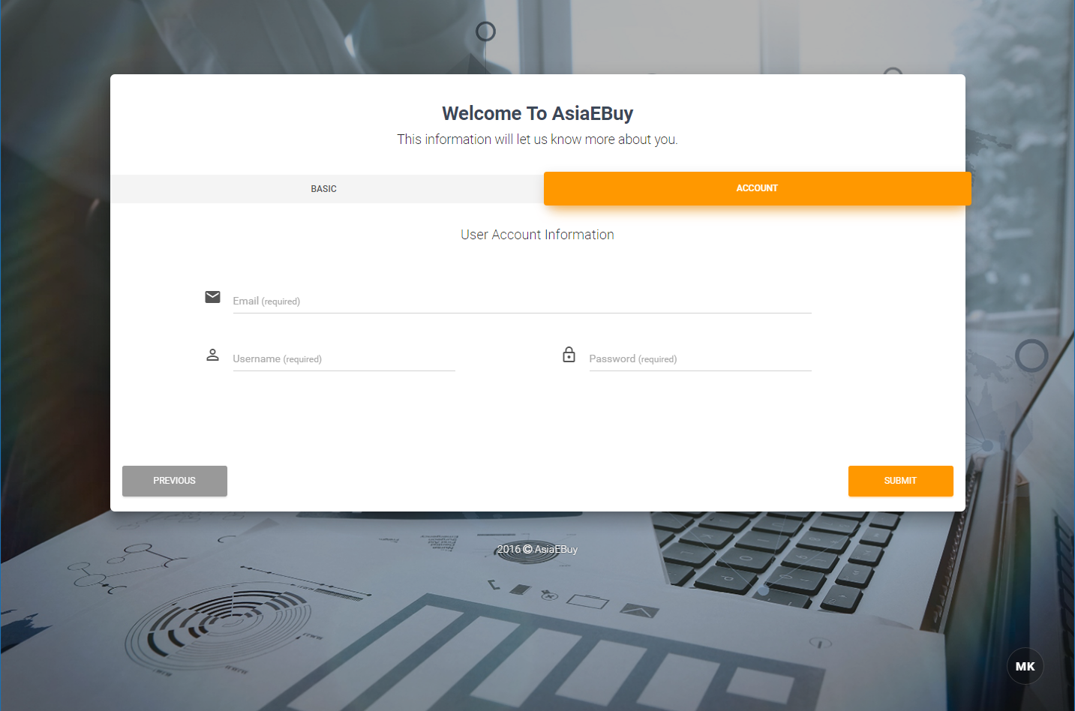

**BUYER**

**GUIDE BUYING**

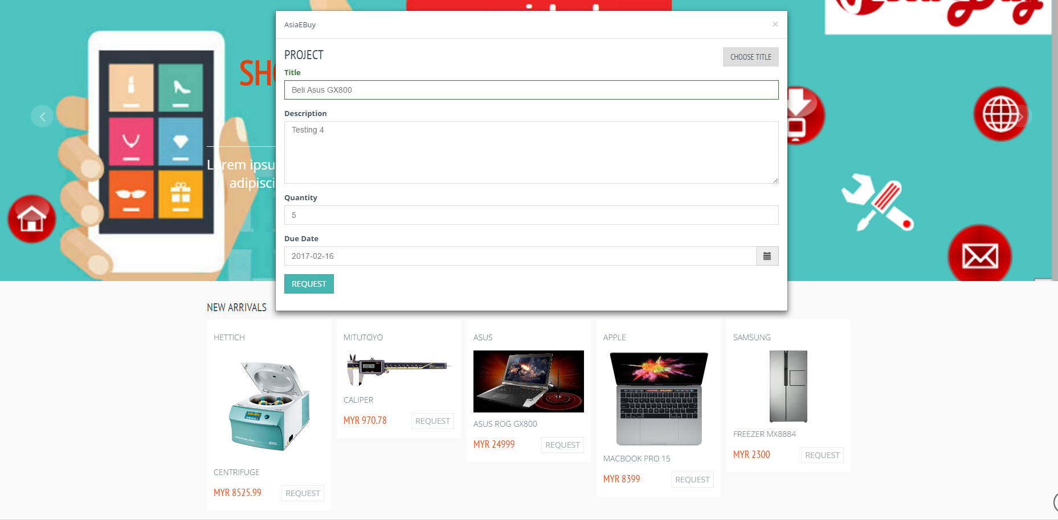

**BUYER**

**SOURCING PAGE**

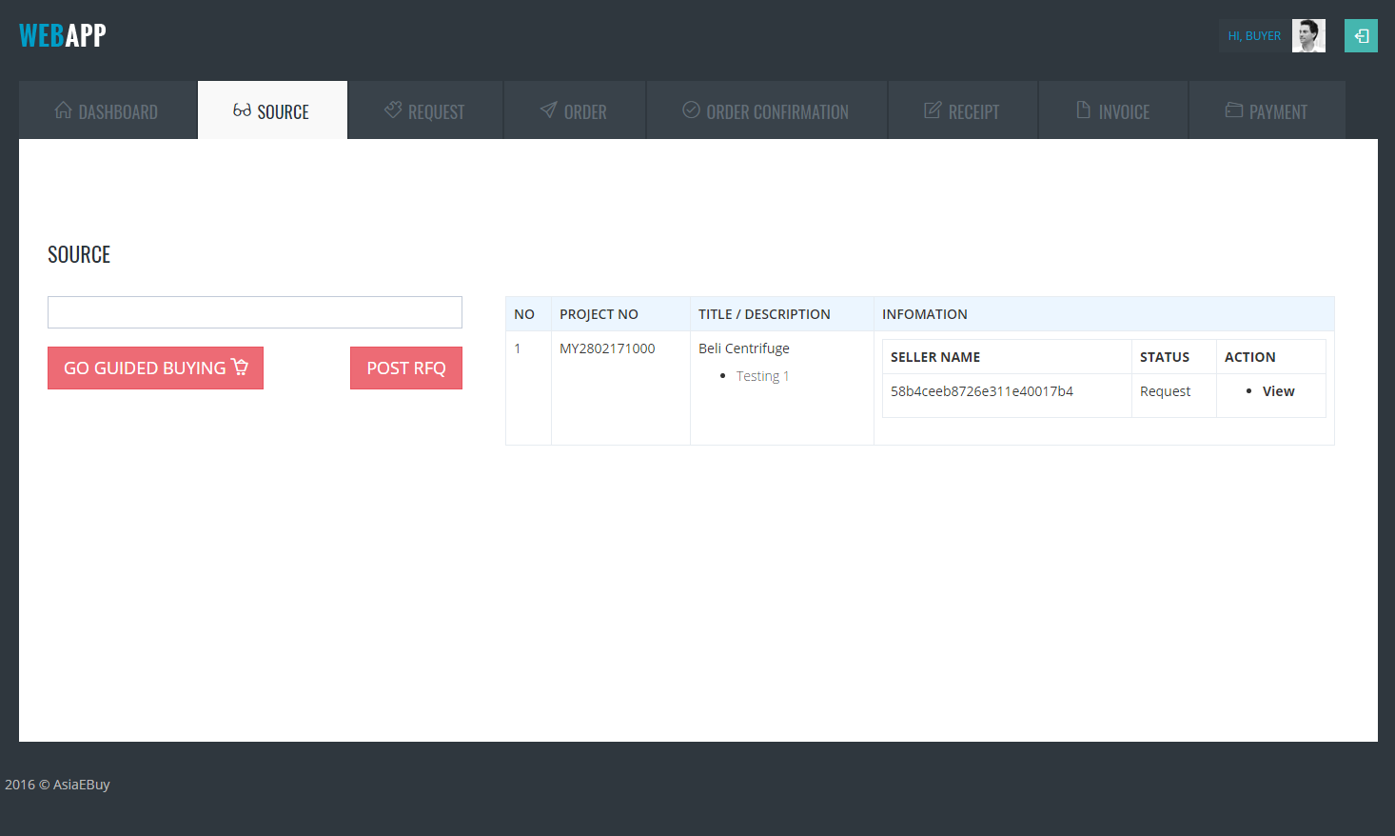

**SELLER**

**LEAD PAGE**

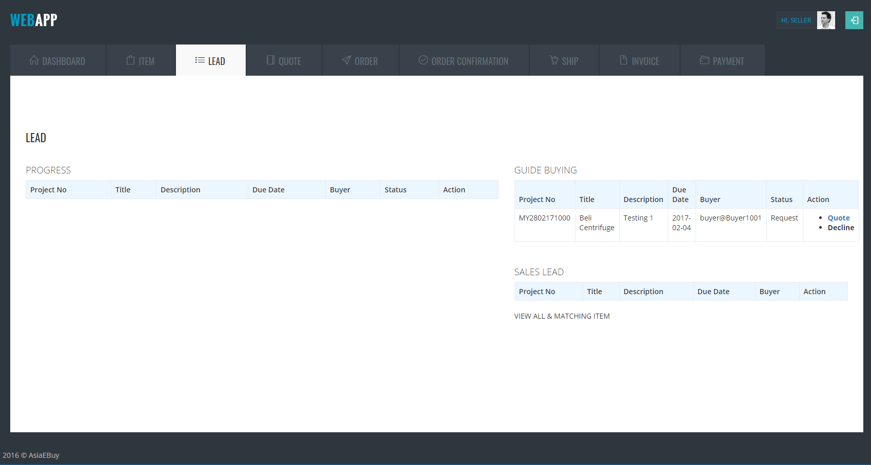

**SELLER**

**QUOTE PAGE**

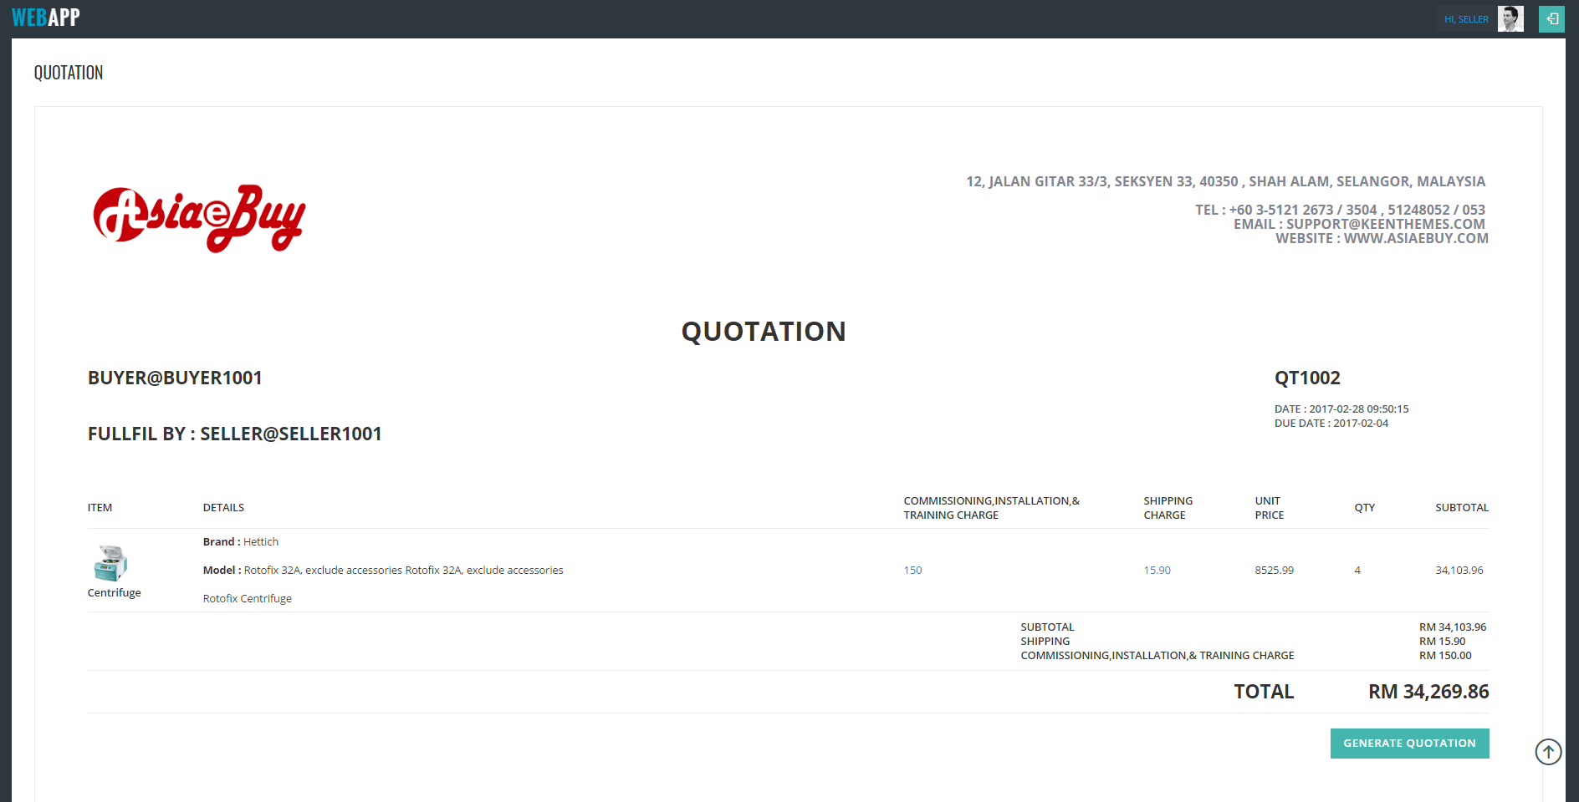

**BUYER**

**PURCHASE REQUITISION PAGE**

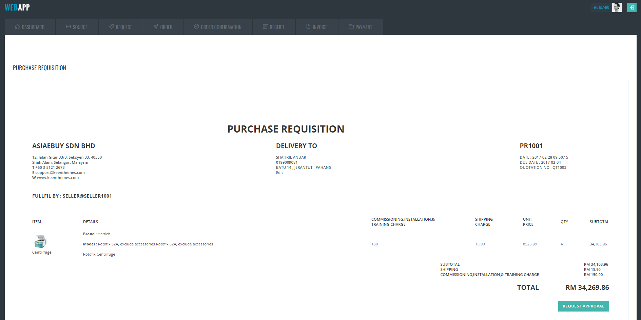

**APPROVAL**

**PURCHASE REQUITISION APPROVAL PAGE**

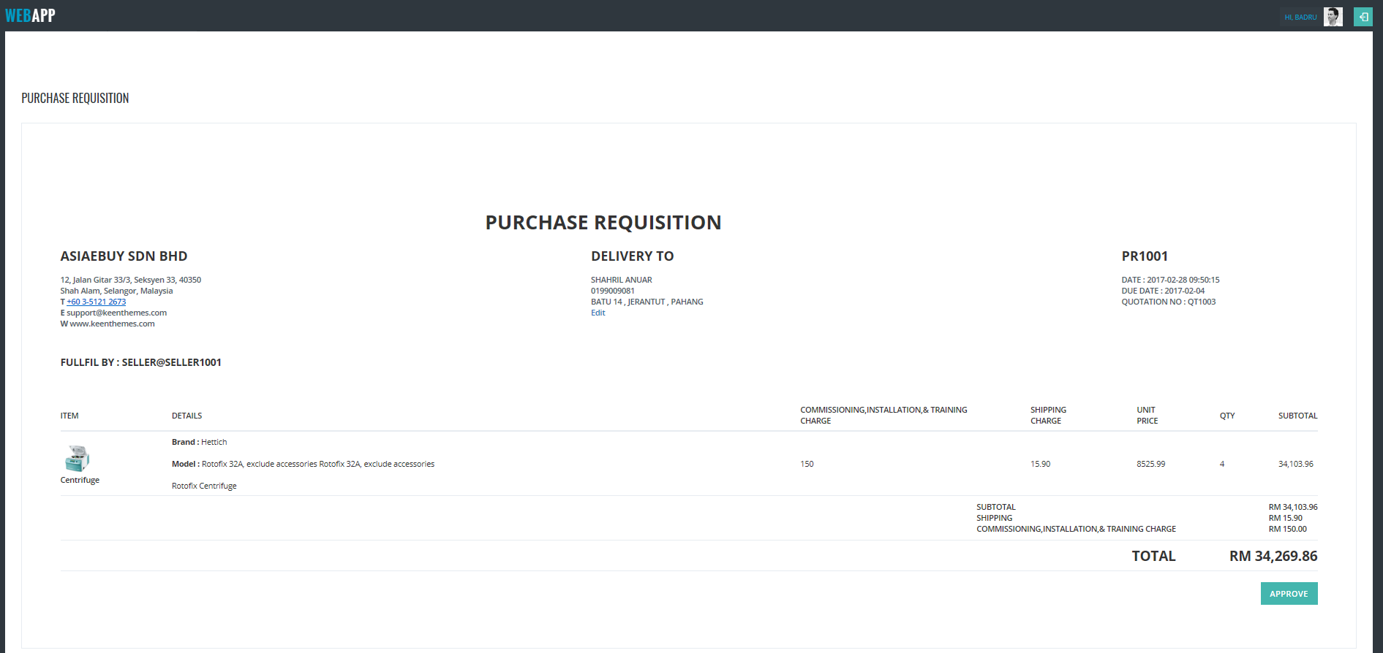

**BUYER**

**PURCHASE ORDER PAGE**

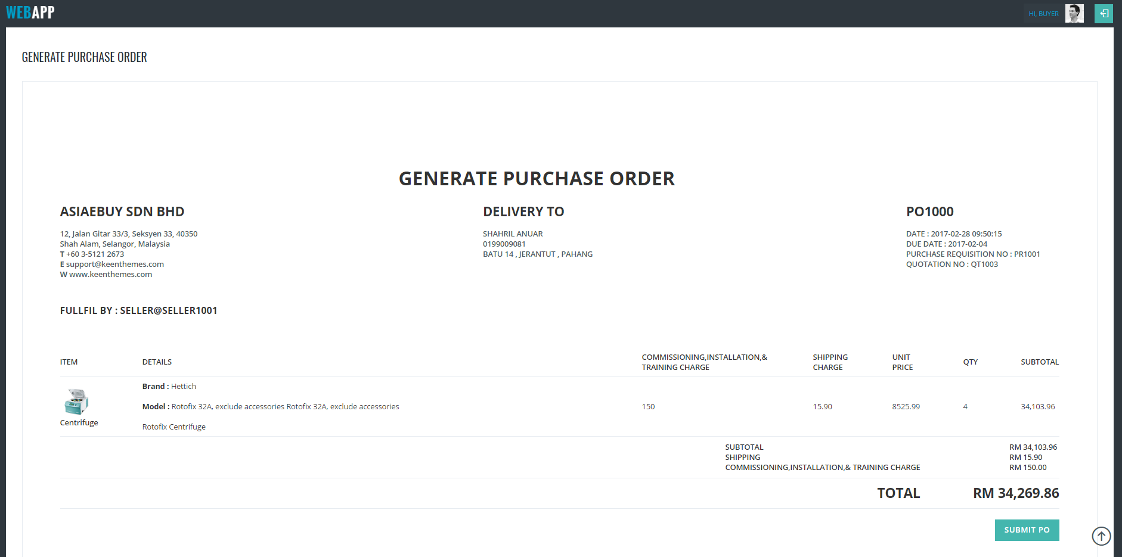

**SELLER**

**CONFIRM ACCEPT PURCHASE ORDER**

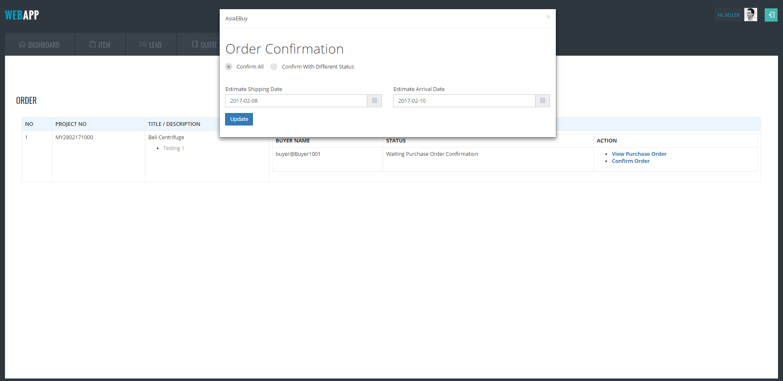

**BUYER**

**ORDER CONFIRMATION PAGE**

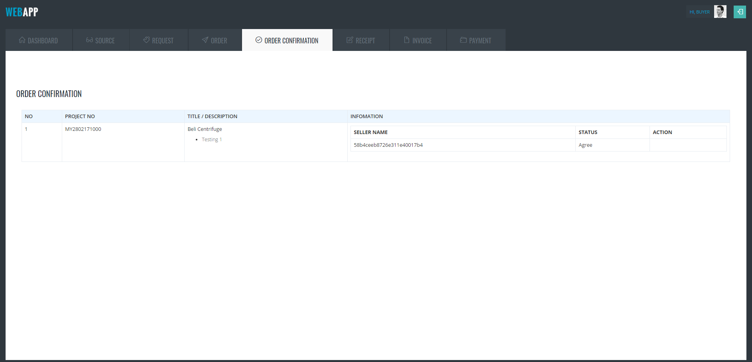

**SELLER**

**DELIVERY ORDER PAGE**

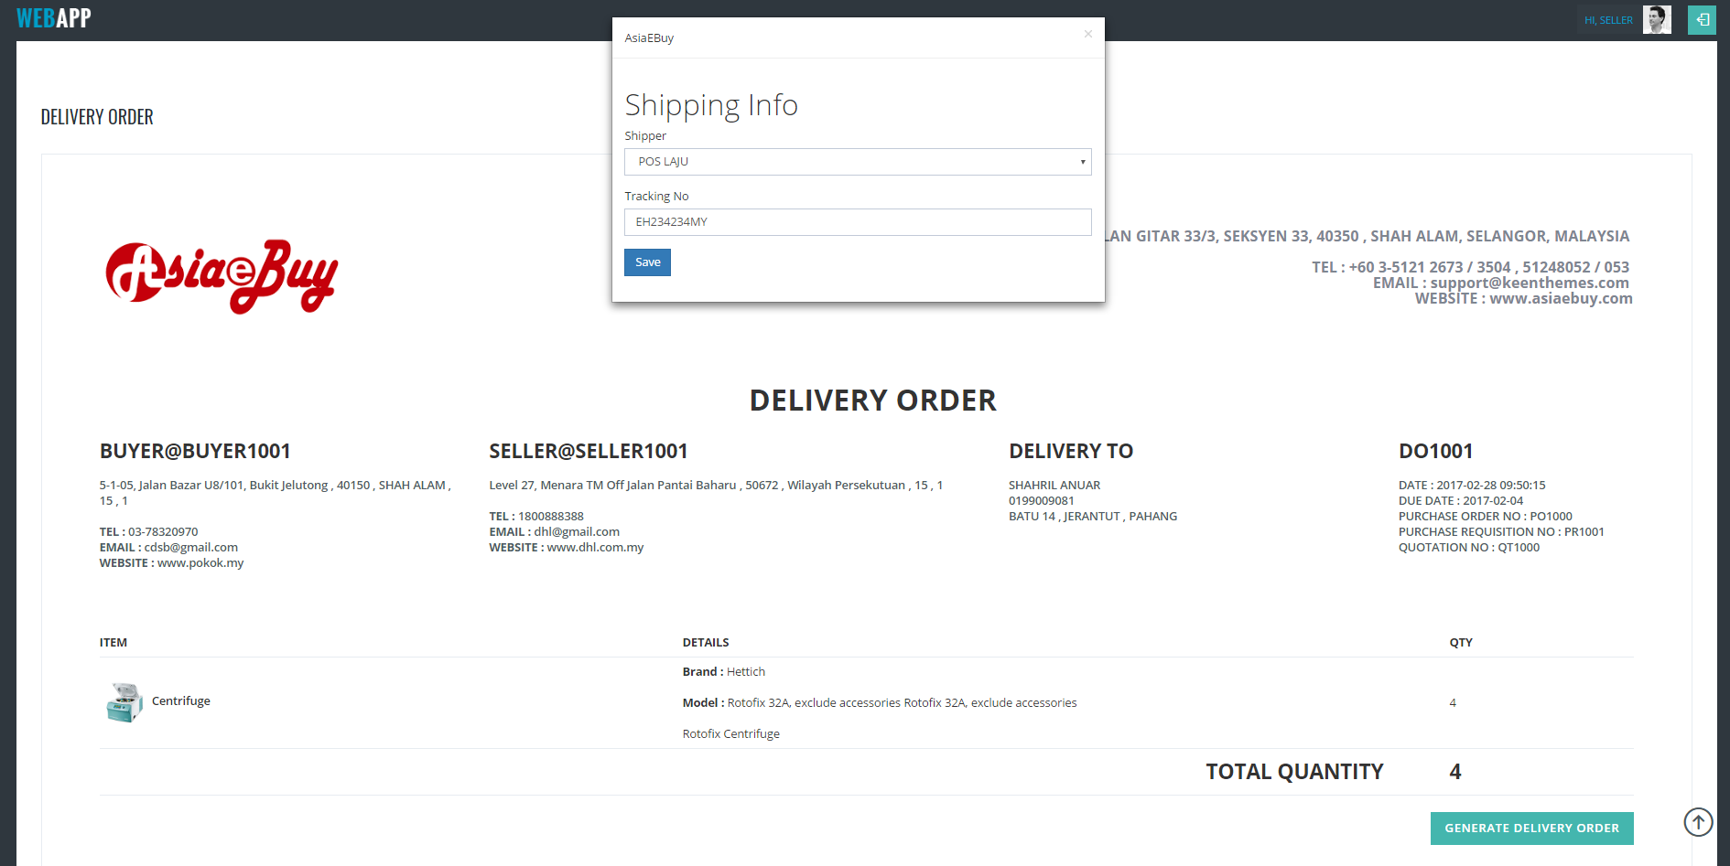

**BUYER**

**RECEIPT PAGE**

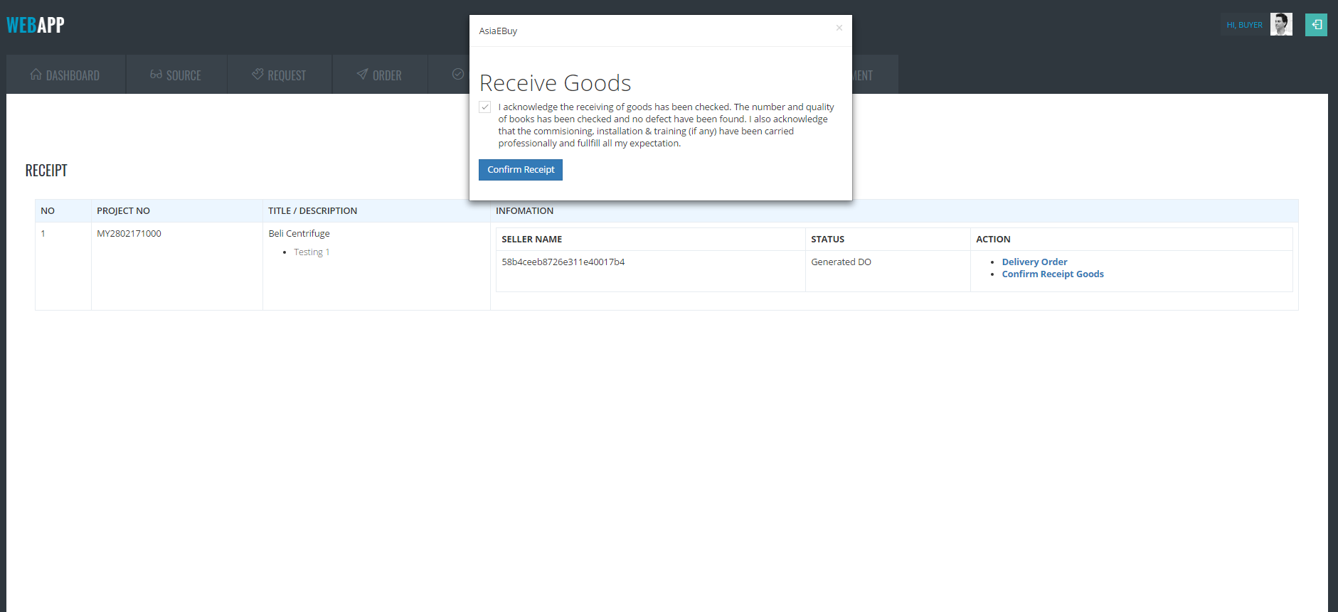

**BUYER**

**INVOICE PAGE**

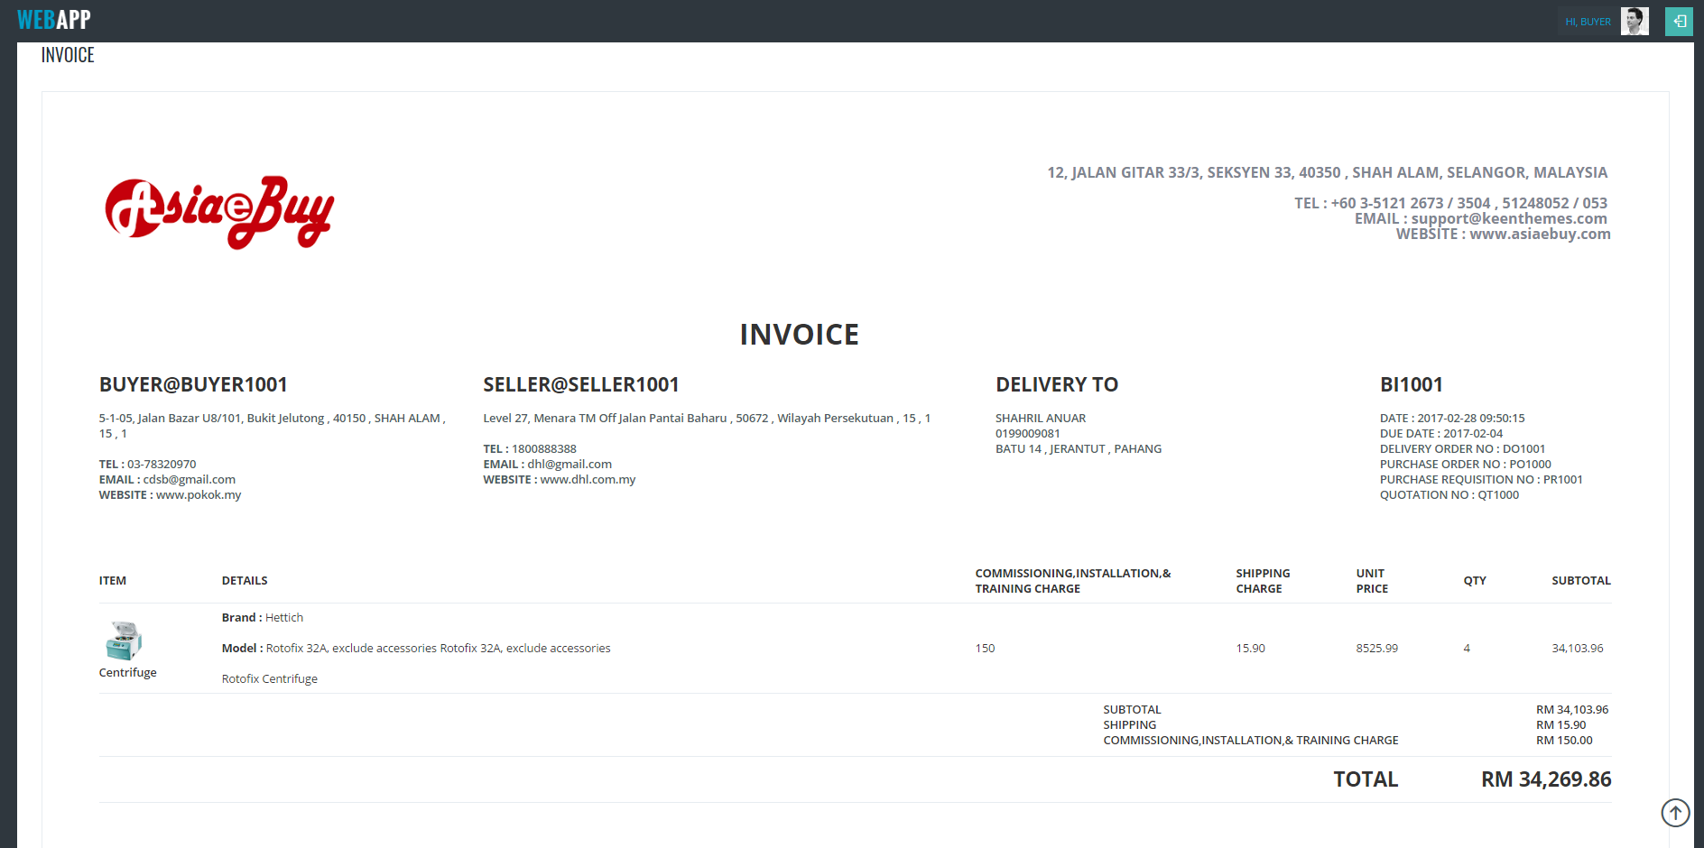

**SELLER**

**INVOICE PAGE**

